**DX Spots Window**

# Hal Miller KB1ZQ, Geoff Anderson G3NPA, Jim Hargrave W5IFP, Aki Yoshida JA1NLX and Gerry Hohn VE6LB

## 1.0 GENERAL

The DX Spot window uses inputs from the Telnet Cluster window to display received DX Spots to display received DX Spots, and it handles max 300 to 1000 DX Spots. The number of max DX Spots can be specified in Logger32 Shortcut Properties.

This is a sample for max 300 DX Spots.

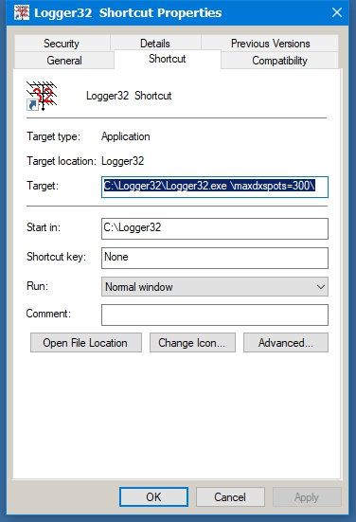

DXSW_40

**Note**: Information on how to send a DX spot to a cluster may be found in the Logbook Entry Window topic.

Operators with computer-controlled radios or CAT capabilities can also use this window to partially control their radios. By clicking on a spot, the radio will change frequency to the DX spot frequency and mode based on the operator's band plan allowing quick movement to a needed country or station. Then by right-clicking on the window one can go back to the original frequency by clicking on Reset radio frequency, this makes grabbing stations that pop onto the band easier. Please remember to verify the stations call before transmitting, as stations do move and another may have replaced the station you are looking for. With clusters being tied via the internet, spots are not always accurate.

**Note**: Clicking a DX spot while holding down the <**Shift**> or <**Ctrl**> keys now sends the DX spot frequency and mode to VFO-B of some SO2V-capable radios. This initial release supports a limited number of SO2V radio makes/models. If your radio did not make this initial release, please let Bob know the make/model and the command to set VFO-B's frequency and mode. It does not matter whether your radio actually has a second- or sub-receiver, just so long as it has two VFOs that can be commanded through the serial port. If you are operating SO2R, the same SHIFT or CTRL-click on a DX spot sends the spot frequency and mode to VFO-A of the non-focus radio.

Some or all of the entries in the table will be highlighted as the spots are displayed, with the information for this highlight being derived from the active logbook, for the selected operator(s) and for the QSL type. The user selects the operator and QSL type from a menu within the Worked Confirmed Window. The Dx Spot and Worked/Confirmed window title bars display that selection

The spots are displayed using the following columns, which are user-definable as to font, color and size (Grid Appearance):

* + **?** Worked before and LotW user columns;
  + **DX Spot** Call sign of the spotted station
  + **Pfx** Prefix or Country
  + **Freq** Frequency
  + **Comment** Free format comments
  + **Time** Time the spot was posted
  + **Origin** The originating stations callsign

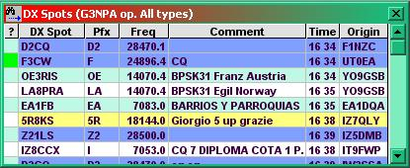

DXSW_1

The Freq format is selectable. Click Setup|DX spots in the main Menu and check your favorite frequency format. This format is used to send DX spots as well.

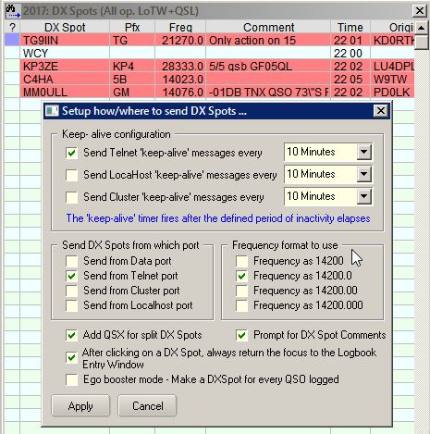

DXSW_1A

Configuring the DX Spot Window makes extensive use of multiple pop-up and linked menus.

Right-clicking on the DX Spot window displays a pop-up menu that provides the operator with various functions and access to additional pop-up menus.

Individual column widths in the DX spot table may be altered to suit the user by placing the cursor over the divider between columns in the title section, i.e., between DX Spot and Pfx or Comment and Time. The cursor will change to a double-ended arrow with a left-click, hold and drag will allow changing the size.

When clickig on the row where callsign does not exist in callsign column you see like this. (ECY, WWV, ANNOUNCE etc)

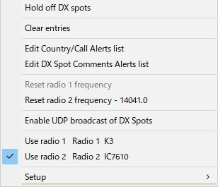

new DXSW_2

When clicking on the row where callsign exist in callsign column you see like this.

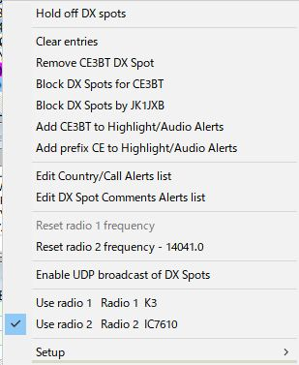

DXSW_2A

## 2.0  MAIN MENU

The Main menu items provide the following functionality:

### 2.1 Hold off DX Spots

This item is a toggle, and when checked, the display of incoming spots is disabled and the DX Spot window Title bar will display "On Hold". When un-checked, the display of incoming spots is again enabled and the title bar will revert to the normal "DX Spots" display.



DXSW_36

### 2.2 Clear entries

Clears all entries from the DX Spots Window.

### 2.3 Remove xxxxx DX Spot

If you have clicked on a specific DX spot, then this menu option will appear, allowing for the removal of that particular spot from the table and the map displays. In the example below, the cursor has been clicked on HZ1TT ~~C5YK~~. Selection of this option will remove ALL occurrences of that callsign. This action also removes the spots from the DX Spot map and the appropriate bandmap (see the Bandmap topic).

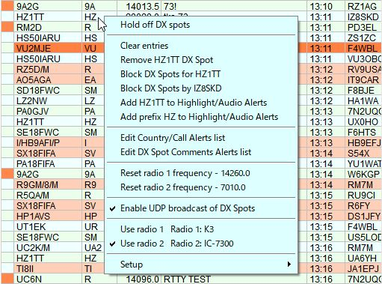

DXSW_37

### 2.4 Block DX Spot for xxxxx